Homework 2

Type your answers in this word file and submit it in PDF format.

**I. Question 1** (10 points)

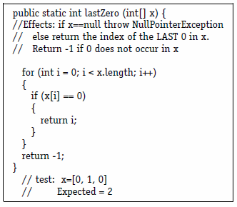

1. Identify the fault
2. Identify a test case (test inputs) that results in no error. (Provide an answer that is different from the answer in the slides.)
3. Identify a test case that results in an error, but not a failure. (Provide an answer that is different from the answer in the slides.)

**II. Question 2** (40 points)

One of the fields on a form contains a text box that accepts an exam grade (out of 100).

1. greater than or equal to 90, but less than or equal to 100 – output 'A'

2. greater than or equal to 80, but less than 90 – output 'B'

3. greater than or equal to 70, but less than 80 - output 'C'

4. greater than or equal to 0, but less than 70 - output 'D'

5. All other inputs -output ‘invalid’

Design **7** test cases using Equivalence partitioning. (Define valid and invalid classes(partition) first)

|  |  |  |  |
| --- | --- | --- | --- |
| Test Case ID | Input | Partition | Output |
|  |  |  |  |
|  |  |  |  |
|  |  |  |  |
|  |  |  |  |
|  |  |  |  |
|  |  |  |  |
|  |  |  |  |